**Common Instrument Interfaces**

Instrument interfaces play pivot role in all kind of digital equipments. It is the job of these equipments to make a symbiotic liaison between the external environment data and the process data.

Some of the main considerations for PC based instrument interfaces depends on the type of connector (pinouts) on the instrument, type of cables needed, electrical properties involved, signal levels, grounding, cable length, communication protocols used, and the software drivers available.

Possible Modes of communication:

Transmission of digital data through a transmission medium can be performed either in serial or in parallel mode. In the serial mode, one bit is sent per clock tick, whereas in parallel mode multiple bits are sent per clock tick.



Different modes of transmission

Parallel Transmission:

Parallel transmission involves grouping several bits, say n, together and sending all the n bits at a time. This can be accomplishes with the help of eight wires bundled together in the form of a cable with a connector at each end. Additional wires, such as request (req) and acknowledgement (ack) are required for asynchronous transmission.



Parallel mode of communication with n = 8

Serial Transmission:

Serial transmission involves sending one data bit at a time. It uses a pair of wire for communication of data in bit-serial form.

RS-232, RS-422, RS-423 and RS-485 are each a recommended standard (RS-XXX) of the Electronic Industry Association (EIA) for asynchronous serial communication and have more recently been rebranded as EIA-232, EIA-422, EIA-423 and EIA-485.

RS-232 :

This is the original serial port interface “standard” and it stands for “Recommended Standard Number 232” or more appropriately EIA Recommended Standard 232 is the oldest and the most popular serial communication standard. It was first introduced in 1962 to help ensure connectivity and compatibility across manufacturers for simple serial data communications.

RS-232 is a standard communication protocol for linking computer and its peripheral devices to allow serial data exchange. In simple terms RS232 defines the voltage for the path used for data exchange between the devices. It specifies common voltage and signal level, common pin wire configuration and minimum, amount of control signals. As mentioned above this standard was designed with specification for electromechanically teletypewriter and modem system and did not define elements such as character encoding, framing of characters, error detection protocols etc that are essential features when data transfer takes place between a computer and a printer. Without which it could not be adopted to transfer data between a computer and a printer. To overcome this problem a single integrated circuit called as UART known as universal asynchronous receiver/transmitter is used in conjunction with RS232.

The current revision is TIA-232-F Interface Between Data Terminal Equipment and Data Circuit-Terminating Equipment Employing Serial Binary Data Interchange, issued in 1997.

DTE-A DTE stands for data terminal equipment is an end instrument that convert user information into signals or reconverts the receive signal. It is a functional unit of station that serves as data source or data sink and provides for communication control function according to the link protocol. A male connector is used in DTE and has pin out configuration.

DCE-A DCE stands for data communication equipments. It sits between the DTE and data transmission circuit for example modem. A DCE device uses a female connector which has holes on the surface to hold male connector.



Interfacing to the medium

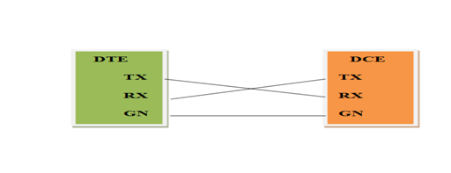

Cabling Options:

RS-232 cables are commonly available with either 4, 9 or 25-pin wiring. The 25-pin cable connects every pin; the 9-pin cables do not include many of the uncommonly used connections; 4-pin cables provide the bare minimum connections, and have jumpers to provide “handshaking” for those devices that require it. These jumpers connect pins 4, 5 and 8, and also pins 6 and 20. The advent of the IBM PC AT has created a new wrinkle in RS232 communications. Rather than having the standard 25-pin connector, this computer and many new expansion boards for PC’s feature a 9-pin serial port. To connect this port to a standard 25-pin port, a 9-to-25-pin adaptor cable can be utilized, or the user can create his own cable specifically for that purpose.

Selecting a Cable:

The major consideration in choosing an RS232 cable is, what devices are to be connected? First, are you connecting two DTE devices (null modem cable) or a DTE device to a DCE device (modem cable)? Second, what connectors are required on each end, male or female, 25-pin or 9-pin (AT style)? Usually, it is recommended that the user obtain the two devices to be connected, and then determine which cable is required.

RS232 Specifications:

TRANSMITTED SIGNAL VOLTAGE LEVELS:

Binary 0: +5 to +15 Vdc (called a “space” or “on”)

Binary 1: -5 to -15 Vdc (called a “mark” or “off”)

RECEIVED SIGNAL VOLTAGE LEVELS:

Binary 0: +3 to +13 Vdc

Binary 1: -3 to -13 Vdc

DATA FORMAT:

Start bit: Binary 0

Data: 5, 6, 7 or 8 bits

Parity: Odd, even, mark or space (not used with 8-bit data)

Stop bit: Binary 1,

one or two bits

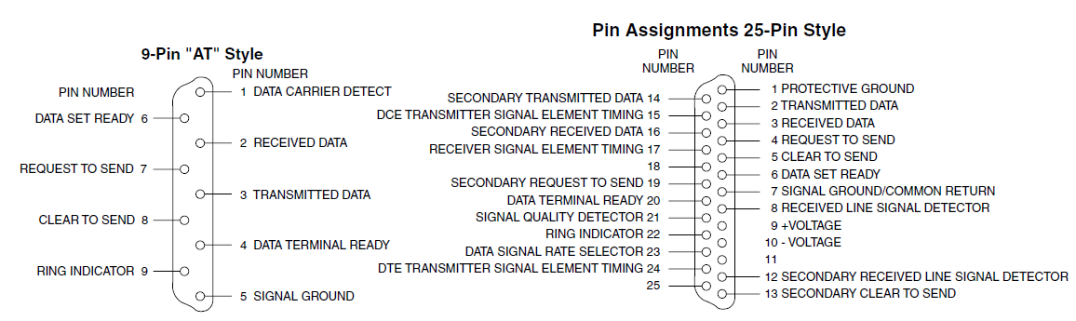

Signal Descriptions

– TxD – This pin carries data from the computer to the serial device

– RXD – This pin carries data from the serial device to the computer

– DTR signals – DTR is used by the computer to signal that it is ready to communicate with the serial device like modem. In other words, DTR indicates the modem that the DTE (computer) is ON.

– DSR – Similarly to DTR, Data set ready (DSR) is an indication from the modem that it is ON.

– DCD – Data carrier detect (DCD) indicates that carrier for the transmit data is ON.

– RTS – This pin is used to request clearance to send data to a modem.

– CTS – This pin is used by the serial device to acknowledge the computer’s RTS signal. In most situations, RTS and CTS are constantly on throughout the communication session.

– Clock signals (TC, RC, and XTC) – The clock signals are only used for synchronous communications. The modem or DSU extracts the clock from the data stream and provides a steady clock signal to the DTE. The transmit and receive clock signals need not have to be the same, or even at the same baud rate.

– CD – CD stands for Carrier detect. Carrier detect is used by a modem to signal that it has a made a connection with another modem, or has detected a carrier tone. In other words, this is used by the modem to signal that a carrier signal has been received from a remote modem.

**Limitations of RS-232:**

* The device works well only for short distances.
* Since the signals are sent and received on a single line there are more chances of the signal being subject to noise.
* The data transmission rates are slow.

Advantages:

* The device is most commonly available in almost all PCs and laptops
* The wiring required for communication between the serial devices is very simple and person who works on the computer can connect without any assistance.
* The cost of the device is also too less and affordable.

RS 485:

RS485 is an EIA standard for multipoint communications. It supports several types of connectors, including DB-9 and DB-37. RS485 meets the requirements for a truly multipoint communications network, and the standard specifies up to 32 drivers and 32 receivers on a single (2-wire) bus.The devices can communicate the with a data rate of 100Kbps with upto 4000 feet of distance.

RS-485, like RS-422, can be made full-duplex by using four wires. Since RS-485 is a multi-point specification, however, this is not necessary in many cases. RS-485 and RS-422 can interoperate with certain restrictions.

Converters in general can be used to change the electrical characteristic of one communications standard into another, to take advantage of the best properties of the alternate standard selected. An “Automatic Converter” (RS232<=>RS485) will turn on the RS485 transmitter when data is detected on the RS232 port, and revert back into the receive mode after a character has been sent. This avoids timing problems that are difficult to deal with in typical systems. When full duplex is converted into half-duplex only one device at a time can transmit data. Automatic Converters take care of the timing problems and allow fast communications without software intervention.

Applications:

RS-485 signals are used in a wide range of computer and automation systems.

RS-485 is also used in building automation as the simple bus wiring and long cable length is ideal for joining remote devices. It may be used to control video surveillance systems or to interconnect security control panels and devices such as access control card readers.

Advantages:

* Can communicate at high data rates in multipoint applications.
* Data transmission with longer cable lengths.
* Complete noise immunity.
* Data transmission is bidirectional.

Disadvantages:

* More cables and interconnections are required.
* The device is not used in common.

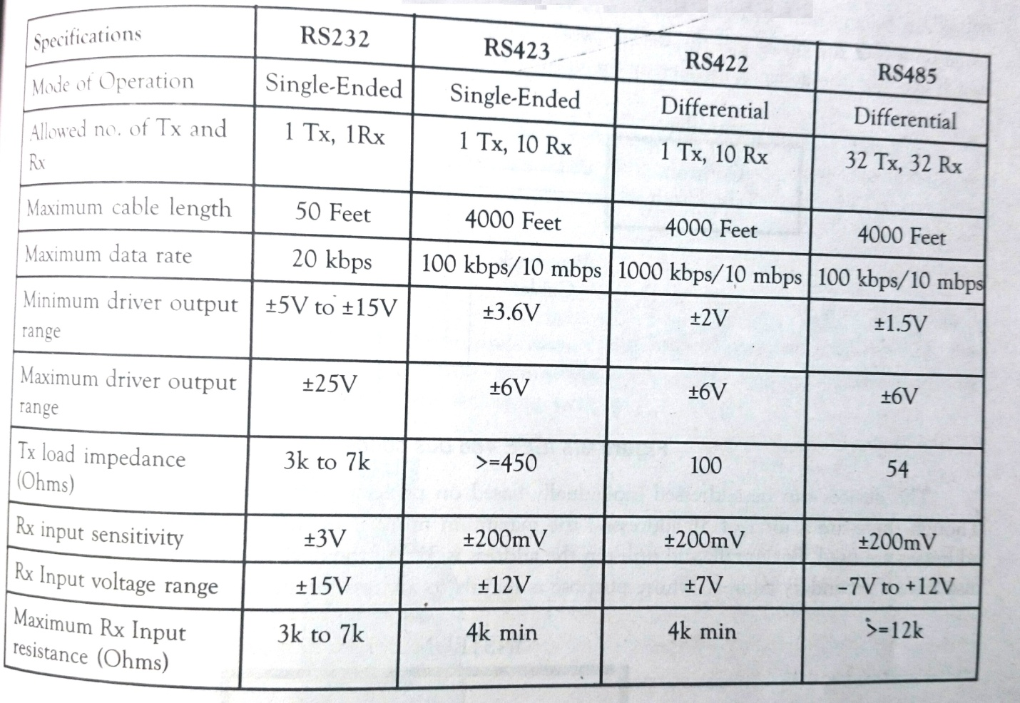

**4–20mA Current Loop:**

Since the 1950s, current loops have been used to transmit transducer data for process monitoring and control. With their low implementation cost, inherent resistance to noise, and ability to carry signals long distances, current loops have proven particularly well-suited for industrial environments.

In electrical signalling an analog current loop is used where a device must be monitored or controlled remotely over a pair of conductors. Only one current level can be present at any time.

A major application of current loops is the industry standard 4-20 mA current loop for process control applications, where they are extensively used to carry signals from process instrumentation to PID controllers, SCADA systems, and Programmable logic controllers. They are also used to transmit controller outputs to the modulating field devices such as control valves. These loops have the advantages of simplicity and noise immunity, and have a large international user and equipment supplier base. Some 4-20 mA field devices can be powered by the current loop itself, removing the need for separate power supplies, and the "smart" HART Protocol uses the loop for communications between field devices and controllers. Various Automation Protocols may replace analog current loops, but 4-20 mA is still a principal industrial standard.

The key advantages of the current loop are:

•The loop can often power the remote device, with power supplied by the controller, thus removing need for power cabling. Many instrumentation manufacturers produce 4-20 mA sensors which are "loop powered".

•The "live" or "elevated" zero of 4 mA allows powering of the device even with no process signal output from the field transmitter.

•The accuracy of the signal is not affected by voltage drop in the interconnecting wiring.

•It has high noise immunity as it is low impedance circuit usually through twisted pair conductors.

•It is self-monitoring; currents less than 3.8 mA or more than 20.5 mA are taken to indicate a fault.[1]

•It can be carried over long cables up to the limit of the resistance for the voltage used.

•In line displays can be inserted and powered by the loop, as long as total allowable loop resistance is not exceeded.

•Easy conversion to voltage using a resistor.

•Loop powered "I to P" (current to pressure) converters can convert the 4-20 mA signal to a 3-15 psi pneumatic output for control valves, allowing easy integration of 4-20 mA signals into existing pneumatic plant.

The Fundamentals of 4-20 mA Current Loops

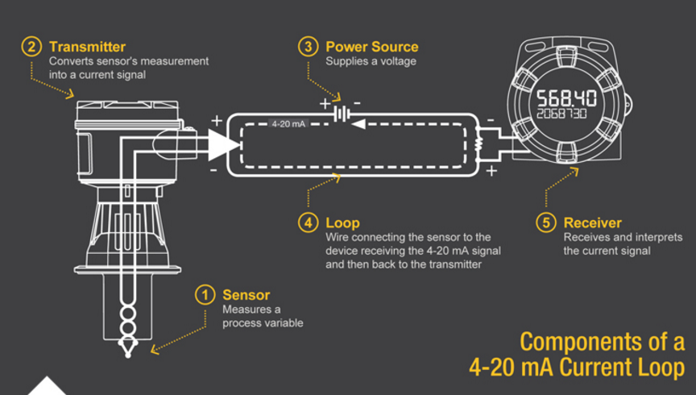

Components of a 4-20 mA Loop:

1. Sensor

A sensor typically measures temperature, humidity, flow, level or pressure.

2. Transmitter

Second, whatever the sensor is monitoring, there needs to be a way to convert its measurement into a current signal, between four and twenty milliamps. This is where a transmitter will come into play. If, for instance, a sensor was measuring the height of a fifty foot tank, the transmitter would need to translate zero feet as the tank being empty and then transmit a four milliamp signal. Conversely, it would translate fifty feet as the tank being full and would then transmit a twenty milliamp signal. If the tank were half full the transmitter would signal at the halfway point, or twelve milliamps.

3. Power Source:

In order for a signal to be produced, there needs to be a source of power. There are many common voltages that are used with 4-20 mA current loops (9, 12, 24, etc.) depending on the particular setup. When deciding on what voltage of power supply to use for your particular setup, be sure to consider that the power supply voltage must be at least 10% greater than the total voltage drop of the attached components (the transmitter, receiver and even wire). The use of improper power supplies can lead to equipment failure.

4. Loop

In addition to an adequate VDC supply, there also needs to be a loop, which refers to the actual wire connecting the sensor to the device receiving the 4-20 mA signal and then back to the transmitter. The current signal on the loop is regulated by the transmitter according to the sensor's measurement. This component is typically overlooked in a current loop setup because wire is so intrinsic to any modern electronic system, but should be considered in our exploration of the fundamentals. While the wire itself is a source of resistance that causes a voltage drop on the system, it is normally not a concern, as the voltage drop of a section of wire is minuscule. However, over long distances (greater than 1,000 feet) it can add up to a significant amount, depending on the thickness (gauge) of the wire.

5. Receiver

Finally, at someplace in the loop there will be a device which can receive and interpret the current signal. This current signal must be translated into units that can be easily understood by operators, such as the feet of liquid in a tank or the degrees Celsius of a liquid. This device also needs to either display the information received (for monitoring purposes) or automatically do something with that information. Digital displays, controllers, actuators, and valves are common devices to incorporate into the loop. These components are all it takes to complete a 4-20 mA current loop. The sensor measures a process variable, the transmitter translates that measurement into a current signal, the signal travels through a wire loop to a receiver, and the receiver displays or performs an action with that signal.

Advantages:

* The 4-20 mA current loop is the dominant standard in many industries.
* It is the simplest option to connect and configure.
* It uses less wiring and connections than other signals, greatly reducing initial setup costs.
* Better for traveling long distances, as current does not degrade over long connections like voltage.
* It is less sensitive to background electrical noise.
* Since 4 mA is equal to 0% output, it is incredibly simple to detect a fault in the system.

Disadvantages:

* Current loops can only transmit one particular process signal.
* Multiple loops must be created in situations where there are numerous process variables that require transmission. Running so much wire could lead to problems with ground loops if independent loops are not properly isolated.
* These isolation requirements become exponentially more complicated as the number of loops increases.

GPIB:

In 1965, Hewlett-Packard designed the Hewlett-Packard Interface Bus (**HP-IB** ) to connect their line of programmable instruments to their computers. Because of its high transfer rates (nominally 1 Mbytes/s), this interface bus quickly gained popularity. It was later accepted as IEEE Standard 488-1975, and has evolved to ANSI/IEEE Standard **488.1**-1987. Today, the name **G** eneral **P**urpose **I**nterface **B**us (**GPIB**) is more widely used than HP-IB. ANSI/IEEE **488.2**-1987 strengthened the original standard by defining precisely how controllers and instruments communicate. **S**tandard **C**ommands for **P**rogrammable **I**nstruments (**SCPI** ) took the command structures defined in IEEE 488.2 and created a single, comprehensive programming command set that is used with any SCPI instrument.

Each instrument had its own interface electronics and a standard set of responses to commands. The GPIB bus was formally adopted as the IEEE STD 488 in 1978. Controllers have the ability to send commands, to talk data onto the bus and to listen to data from devices. Devices can have talk and listen capability. Control can be passed from the active controller (Controller-in-charge) to any device with controller capability. One controller in the system is defined as the System Controller and it is the initial controller-in-charge (CIC).

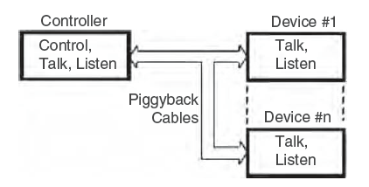

IEEE 488 bus concept

Each device has a primary address between 0 and 30. Address 31 is the unlisten or untalk address. Devices can also have secondary addresses that can be used to address device functions.

The IEEE-488 Standard defined an instrument with interface and device partitions as shown in below. Interface messages and addresses are sent from the controller-in-charge to the device’s interface function. Instrument particular commands such as range, mode, etc., are data messages that are passed through the Interface to the device.

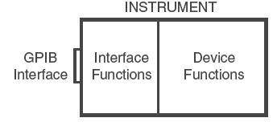

IEEE 488 instrument

Types of GPIB Messages:

GPIB devices communicate with other GPIB devices by sending device dependent

messages and interface messages through the interface system.

**Device-dependent messages,---** often called data or data messages, contain device-specific information, such as programming instructions, measurement results, machine status, and data files.

**Interface messages**---- manage the bus. Usually called commands or command messages, interface messages perform such functions as initializing the bus, addressing and unaddressing devices, and setting device modes for remote or local programming.

The term “command” as used here should not be confused with some device instructions that are also called commands. Such device-specific commands are actually data messages as far as the GPIB interface system itself is concerned.

Physical Bus Structure:

Physically, the GPIB interface system consists of 16 low-true signal lines and eight ground-return or shield drain lines. The 16 signal lines, discussed later, are grouped into data lines (eight), handshake lines (three), and interface management lines (five).

Data Lines:

The eight data lines, DIO1 through DIO8, carry both data and command messages. The state of the Attention (ATN) line determines whether the information is data or commands. All commands and most data use the 7-bit ASCII or ISO code set, in which case the eighth bit, DIO8, is either unused or used for parity.

Handshake Lines:

– NRFD (not ready for data) – Indicates when a device is ready or not ready to receive a message byte. The line is driven by all devices when receiving commands by listeners when receiving data messages, and by the talker when enabling the HS488 protocol.

– NDAC (not data accepted) – Indicates when a device has or has not accepted a message byte. The line is driven by all devices when receiving commands, and by Listeners when receiving data messages.

– DAV (data valid) – Tells when the signals on the data lines are stable (valid) and can be accepted safely by devices. The Controller drives DAV when sending commands, and the Talker drives DAV when sending data messages.

Three of the lines are handshake lines, NRFD, NDAC, and DAV, which transfer data from the talker to all devices who are addressed to listen. The talker drives the DAV line; the listeners drive the NDAC and NRFD lines. The remaining five lines are used to control the bus’s operation.

– ATN (attention) is set true by the controller-in-charge while it is sending interface messages or device addresses. ATN is false when the bus is transmitting data.

– EOI (end or identify) can be asserted to mark the last character of a message or asserted with the ATN signal to conduct a parallel poll.

– IFC (interface clear) is sent by the system controller to unaddressed all devices and places the interface function in a known quiescent state.

– REN (remote enable) is sent by the system controller and used with other interface messages or device addresses to select either local or remote control of each device.

– SRQ (service request) is sent by any device on the bus that wants service.

**Interface Messages:**

MLA, LAD, and UNL are listen addresses with hex values of 20–3 F. MTA, TAD, and UNT are talk addresses with hex values of 40–5 F. A device normally responds to both talk and listen addresses with the same value. i.e., LAD 4 and TAD 4. Secondary addresses have hex values of 60–7 F. Devices are designed with different IEEE 488 capabilities so not all devices respond to all of the interface messages. Universal messages are recognized by all devices regardless of their address state. Addressed commands are only recognized by devices that are active listeners.

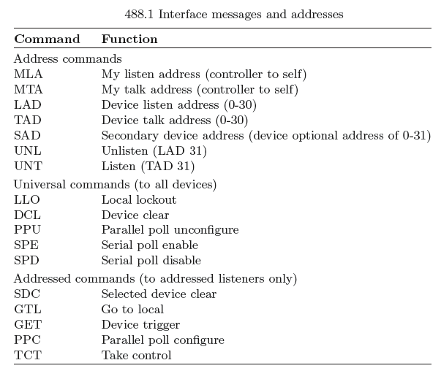

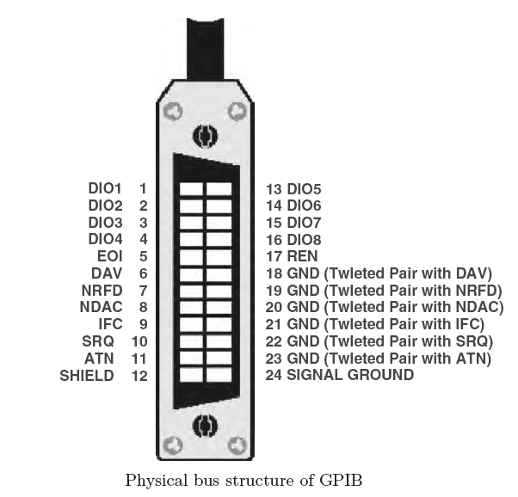

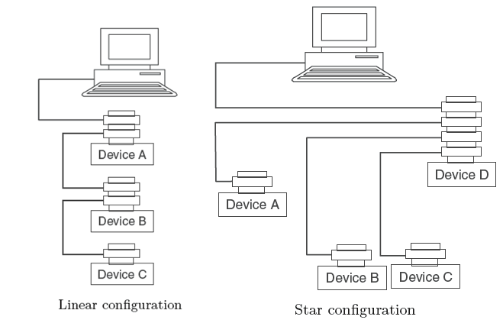

Advantages of GPIB:

* Combines analog I/O, digital I/O, relay drivers, and temperature readings in a ICS Minibox.
* Versatile GPIB module controls almost any device.
* 32-line Digital Interface configurable as gated inputs or latched outputs.
* User configurable to match the application.
* Six analog inputs with programmable ranges measures up to 10V dc.
* Four 0–5V dc analog outputs.
* Controls analog devices.
* High current Relay.
* Drivers sink 300 mA.

**Interface Buses:**

In computer architecture, a bus is a subsystem that transfers data or power between computer components inside a computer or between computers. Modern computer buses can use both parallel and bit-serial connections, and can be wired in either a multidrop or daisy chain topology, or connected by switched hubs, as in the case of Universal Serial Bus (USB).

USB:

In the latest PCs, many of the peripherals such as the keyboard, mouse, scanners, printers, modem and even external CD-ROM drives and CD-writers are connected to the computer through a USB cable. The users wanted the bulky data to be moved around faster, rather than more slowly. So a group of leading computer and telecom firms including IBM, Intel, Microsoft, Compaq, Digital Equipment, NEC, and Northern Telecom got together and developed USB.

USB Versions:

There have been three major USB standards, 3.1 being the newest:

* USB 3.1: Called *Superspeed+*, USB 3.1 compliant devices are able to transfer data at 10 Gbps (10,240 Mpbs).
* [USB 3.0](https://www.lifewire.com/what-is-usb-3-0-2626038): Called *SuperSpeed USB*, USB 3.0 compliant hardware can reach a maximum transmission rate of 5 Gbps (5,120 Mbps).
* [USB 2.0](https://www.lifewire.com/what-is-usb-2-0-2626037): Called *High-Speed USB*, USB 2.0 compliant devices can reach a maximum transmission rate of 480 Mbps.
* [USB 1.1](https://www.lifewire.com/what-is-usb-1-1-2626036): Called *Full Speed USB*, USB 1.1 devices can reach a maximum transmission rate of 12 Mbps.

Architecture of USB:

The USB is a medium-speed serial data bus designed to carry relatively large amounts of data over relatively short cables: up to about 5m long. It can support data rates of up to 12Mbs−1 (megabits per second), which is fast enough for most PC peripherals such as scanners, printers, keyboards, mice, joysticks, graphics tablets, low-res digital cameras, modems, digital speakers, low speed CD-ROM and CD-writer drives, external Zip disk drives, and so on. The USB is an addressable bus system, with a 7-bit address code so it can support up to 127 different devices or nodes. However, it can have only one host. So a PC with its peripherals connected through the USB forms a star Local Area Network (LAN).

It can have a device which purely functions as a hub for other node devices, with no separate function of its own. This expansion through hubs is available because the USB supports a tiered star topology.

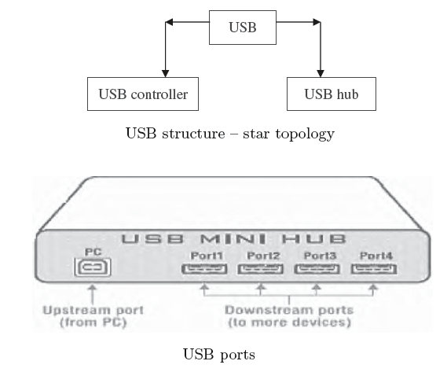

Each USB hub acts as a traffic cop for its network, routing data from the host to its correct address and preventing bus contention clashes between devices trying to send data at the same time. On a USB hub device, the single port is used to connect to the host PC either directly or via another hub known as the upstream port, while the ports used for connecting other devices to the USB are known as the downstream ports.

Need for USB:

The USB is host controlled. There can only be one host per bus. The specification in itself does not support any form of multi master arrangement. This is aimed at and limited to single point to point connections such as a mobile phone and personal organizer and not multiple hub, multiple device desktop configurations.

Up to 127 devices can be connected to any one USB bus at any one given time.

USB connectors come in many shapes and sizes. Every version of USB connector including standard, Mini, and Micro have two or more variations of connectors.

USB cables are available in multiple lengths, from around 3 feet to just over 16 feet in length. The maximum length of a USB cable is 16 feet 5 inches (5 meters) for high-speed devices and 9 feet 10 inches (3 meters) for low-speed devices. These maximum lengths are due to data transfer timing and the risk of data loss if using longer cable lengths. However, by using USB hubs, you can connect two USB cables together to effectively extend the distance between the two devices being connected.

Power Cables:

USB cables consist of two twisted pairs of wires, one pair used to carry the bidirectional serial data and the other pair 5V DC power. Most modern PCs have two USB ports, and each can provide up to 500mA of 5V DC power for bus powered peripherals. Individual peripheral devices (including hubs) can draw a maximum of 100mA from their upstream USB port, so if it require less than this figure for operation it can be bus Powered. If it needs more, it has to use their own power supply such as a plug-pack adaptor. Hubs should be able to supply up to 500mA at 5V from each downstream port, if it is not bus powered. Serial data is sent along the USB in differential or push-pull mode, with opposite polarities on the two signal lines

The data is sent in nonr eturn-to-zero (NRZ) format, with signal levels of 3.3V peak (i.e., 6.6V peak differential).

USB cables use two different types of connectors:

"Type A" connectors head "upstream" toward the computer.

"Type B" connectors head "downstream" and connect to individual devices.



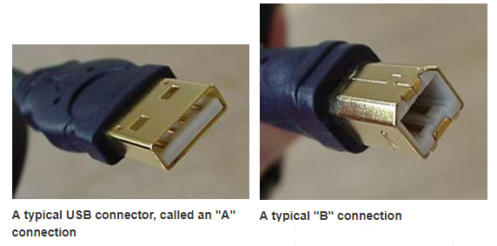

USB is not designed for direct data transfer between PCs. All normal USB connections are made using cables with a Type A plug at one end and a Type B plug at the other; although extension cables with a Type A plug at one end and a Type A socket at the other can also be used, providing the total extended length of a cable is within 5 m.

Data Formats:

USB data transfer is essentially in the form of packets of data, sent back-and forth between the hosts and peripheral devices. However, USB is designed to handle different types of data. The two main formats are the asynchronous mode and synchronous mode.

Asynchronous Mode. This mode is used for transferring data that is not time critical. This format is used to transmit data from a scanner or digital scanner for example to a printer. The packets can be interleaved on the USB with others being sent to or from other devices.

Synchronous Mode. The other main format is synchronous mode, used to transfer data that is time critical, such as audio data to digital speakers, or to/from a modem. These packets must not be delayed by those from other devices.

Data Signaling Rate:

– High speed data is clocked at 480Mbs−1 with a data signaling tolerance of ±500 ppm.

– Full speed data is clocked at 12Mbs−1 with a data signaling tolerance of ±0.25% or 2,500 ppm.

– Low speed data is clocked at 1.50Mbs−1 with a data signaling tolerance of ±1.5% or 15,000 ppm.

Data Packets:

Data on the USB bus is transmitted with the LSB first. USB packets consist of the following fields:

– Sync. All packets must start with a sync field. The sync field is 8 bits long, which is used to synchronize the clock of the receiver with the transmitter. The last two bits indicate the location of the PID field.

– PID. PID stands for Packet ID. This field is used to identify the type of packet that is being sent. Table 6.1 shows the possible values with 4 bits for the PID. To ensure that the data is received correctly, the 4 bits are complemented and repeated, making an 8 bit PID in total.

– ADDR. The address field specifies the device that is designated by the packets. Since the packet size is 7 bits, USB can address 127 devices. Address 0 is not valid, as any device which is not assigned an address must respond to packets sent to address zero.

– ENDP. The endpoint field is made up of 4 bits, allowing 16 possible endpoints. Low speed devices, can only have 2 endpoint additional addresses on top of the default pipe.

– CRC. Cyclic Redundancy Checks are performed on the data within the packet payload. All token packets have a 5-bit CRC while data packets have a 16-bit CRC.

Packet Types:

USB has four different packet types. Token packets indicate the type of transaction to follow, data packets contain the payload, handshake packets are used for acknowledging data or reporting errors and start of frame packets indicate the start of a new frame:

1. Token Packets. There are three types of token packets:

– In – Informs the USB device that the host is ready to read information.

– Out – Informs the USB device that the host is ready to send information.

– Setup – Used to begin control transfers.

Token Packets must conform to the following format:



2. Data Packets. There are two types of data packets each capable of transmitting

0–1,023 bytes of data:

– Data0

– Data1

Data packets have the following format:



Handshake Packets. There are three type of handshake packets which consist simply of the PID

– ACK – Acknowledges that the packet has been successfully received.

– NAK – Reports that the device cannot send nor receive data temporary.

It is also used during Interrupt transaction to inform the host that there is no data to send.

– STALL – The device finds that it is in a state that it requires intervention from the host.

Handshake Packets have the following format:

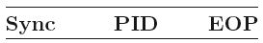

3. Start of Frame Packets. The SOF packet consists of a 11-bit frame number is sent by the host every 1–500 ns. SOF Packets have the following format:



Electrical Specifications:

There are three classes of USB functions,

– Low-powered bus functions

– High-powered bus functions

– Self-powered functions

Low powered bus functions draw all its power from the VBUS and cannot draw any more than one unit load. The USB specification defines a unit load as 100 mA. Low powered bus functions must also be designed to work down to a Bus Voltage (VBUS) of 4.40V and up to a maximum voltage of 5.25V measured at the upstream plug of the device.

High powered bus functions will draw all its power from the bus and cannot draw more than one unit load until it has been configured, after which it can then drain 5 unit loads (500mA Max) provided it asked for this in its descriptor. High power bus functions must be able to be detected and enumerated at a minimum 4.40 V. When operating at a full unit load, a minimum VBUS of 4.75V is specified with a maximum of 5.25 V. Once again, these measurements are taken at the upstream plug. Self-power functions may draw up to 1 unit load from the bus and derive the rest of its power from an external source. If this external source fails, it must have provisions in place to draw no more than 1 unit load from the bus.

Self-powered functions are easier to design according to specifications as it does not involve power consumption. A 1 unit bus powered load allows the detection and enumeration of devices without mains/secondary power applied. No USB device, whether bus powered or self-powered can drive the VBUS on its upstream facing port.

Suspend Mode:

A USB device will enter suspend mode when there is no activity on the bus for greater than 3.0 ms. It then has a further 7 ms to shutdown the device and draws no more than the designated suspend current. Thus the device must draw the rated suspend current from the bus 10 ms after the bus activity has stopped.

– A high speed bus will have microframes sent every 125.0 μs ± 62.5ns.

– A full speed bus will have a frame sent down every 1.000 ms ±500 ns.

– A low speed bus will have an End of Packet (EOP) every 1 ms only in the absence of any low speed data.

Cables or Pipes:

While the device sends and receives data on a series of endpoints, the client software transfers data through pipes. A pipe is a logical connection between the host and endpoint(s).

USB defines two types of pipes:

– Stream pipes have no defined USB format that can send any type of data down a stream pipe and can retrieve the data out of the other end. Data flows sequentially and has a pre-defined direction, either in or out. Stream pipes will support bulk, isochronous and interrupt transfer types. Stream pipes can either be controlled by the host or device.

– Message pipes have a defined USB format. It is host controlled, which are initiated by a request sent from the host. Data is then transferred in the desired direction, dictated by the request. Therefore message pipes allow data to flow in both directions but will only support control transfers.

USB Functions:

Most functions have a series of buffers, typically 8 bytes long. Each buffer belongs to an endpoint – EP0 IN, EP0 OUT, etc. For example, the host sends a device descriptor request. The function hardware will read the setup packet and determine from the address field whether the packet is for itself, and if so will copy the payload of the following data packet to the appropriate endpoint buffer dictated by the value in the endpoint field of the setup token.

Endpoints

Endpoints can be described as sources or sinks of data. As the bus is host centric, endpoints occur at the end of the communications channel at the USB function. At the software layer, device driver may send a packet to devices EP1 for example. As the data is flowing out from the host, it will end up in the EP1 OUT buffer. Endpoints can also be seen as the interface between the hardware of the function device and the firmware running on the function device.

The USB specification defines four transfer/endpoint types:

– Control transfers

– Interrupt transfers

– Isochronous transfers

– Bulk transfers

USB Descriptor:

All USB devices have a hierarchy of descriptors which describe the device type, manufacturer of the device, version of USB supported, number of configuration methods, the number of endpoints and their types etc.The more common USB descriptors are:

– Device descriptors

– Configuration descriptors

– Interface descriptors

– Endpoint descriptors

– String descriptors

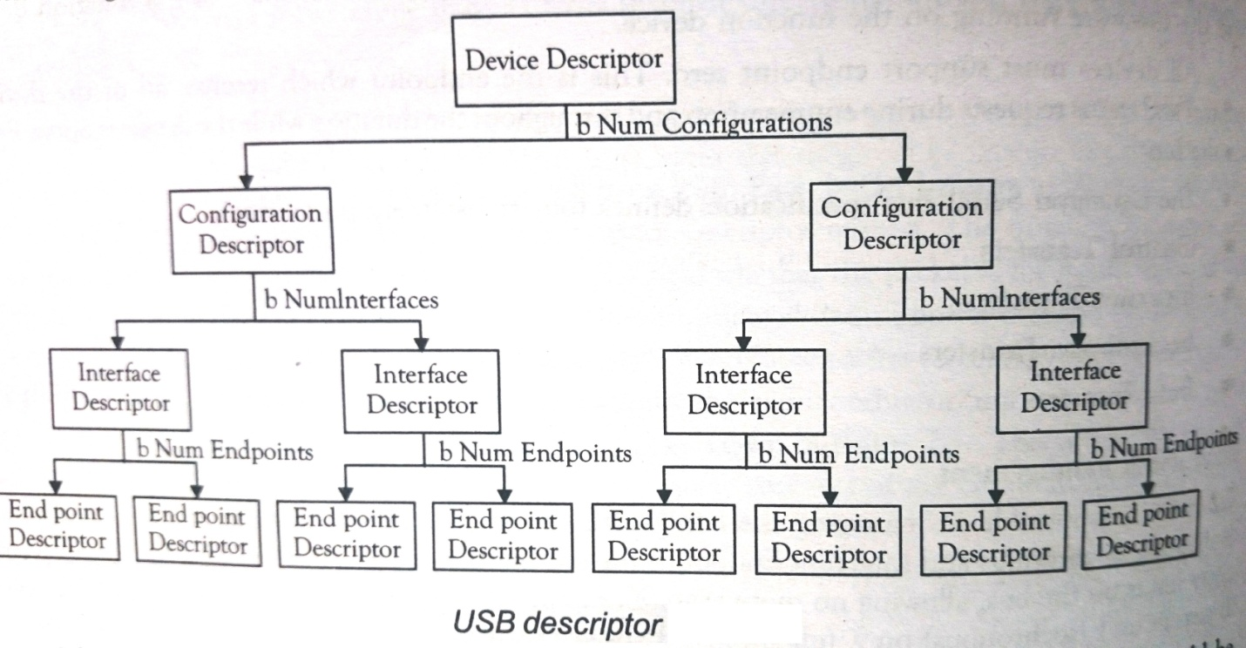

USB devices can only have one device descriptor. The device descriptor includes information such as the USB version with which the device complies with, the Product and Vendor IDs used to load the appropriate drivers and the number of possible configurations the device can have. The configuration descriptor specifies values such as the amount of power this particular configuration uses, if the device is self- or bus-powered and the number of interfaces it possesses. When a device is enumerated, the host reads the device descriptors and can make a decision of which configuration to enable. It can only enable one configuration at a time.

Advantages of USB:

– Always ON, always connected and always ready to go

– Capable of downloading up to 100 times faster than Traditional devices

– Supports upstream data rates up to 30 Mbps

– Enables access to real-time online games

– Downloads megafiles in seconds

– Stand-by switch disconnects the modem from the outside world when not in use

– No telephone line needed

– USB or Ethernet connectivity simplifies installation

**PCI:**

PCI is an abbreviation for **Peripheral Component Interconnect**, which is a term used to describe a common connection interface for attaching computer peripherals to a PC's [motherboard](https://www.lifewire.com/motherboards-system-boards-and-mainboards-2618154), or main circuit board. It is also called a PCI bus. A bus is a term for a path between the components of a computer.

CI was popular from 1995-2005 but was generally replaced by other technology such as USB or PCI Express. Desktop computers after that era may have PCI slots on the motherboard in order to be backward compatible. But the devices that used to be attached as PCI expansion cards are now integrated onto motherboards or attached by other connectors such as PCI Express (PCIe).

First released in 1992, the Peripheral Component Interface (PCI) has rapidly evolved into a viable replacement for the ISA bus, and is the most commonly used method for adding boards to a PC.

The PCI is the high speed bus made by Intel. It is used today in all PCs and other computers for connecting adapters, such as network-controllers, graphics cards, sound cards, etc. The PCI bus is used in everything from tiny embedded systems to enterprise servers. It is fast, cheap, and it solves a large number of problems. It is not quite universal anymore: PCI-X and PCI Express are starting to show up on the scene. For instance, recently POWER4 servers use PCI-X for expansion cards.

PCI devices can have direct access to system memory without waiting on the CPU. A single PCI bus can have up to five devices connected to it, and more importantly, PCI supports bridges, allowing one of those connections to be used for a connection to even more devices. Some individual cards may actually contain an entire PCI bridge chip and separate bus; for instance, dual and quad Ethernet cards often follow this procedure. PCI also allows for a great deal of auto configuration; this was a feature most other buses had offered, which was lacking from ISA.

Architecture of PCI with Two Faces:

– Internal PCI bus, which connects to Enhanced Integrated Development Environment (EIDE) channels on the motherboard.

– The PCI expansion bus, which typically has 3–4 slots for PCI adapters.



PCI architecture

Characteristics of PCI:

* Plug and Play
* High Speed and Wide Bandwidth
* Flexible Bus Mastering
* Voltage Requirements

Plug and Play:

Implementing PCI control registers is vitally important to ensure that Plug and Play, one of PCIs most attractive features, works properly. The system configures itself by having the PCI BIOS access configuration registers on each add-in board at boot-up time. These configuration registers indicate the system about the resources required, (I/O space, memory space, interrupts, etc.). The system can allocate its resources accordingly, making sure that no two devices conflict.

High Speed and Wide Bandwidth:

More than any other bus, PCI can take full advantage of today’s high-power microprocessors to deliver extremely high speed data transfers. The original PCI bus was designed to operate with a 33MHz clock, to provide data transfer speeds up to 132 Mbytes s−1. These 32-bit adapters use multiplexing to achieve 64-bit data transfers. Later versions of PCI enable true 64-bit data transfers using up to a 133MHz clock to enable transfer speeds of up to 1,066 Mbytes s−1. These boards use a longer connector that adds additional 32-bits of data signals.

The high speed data transfers across the PCI bus limits the number of PCI expansion slots that can be built into a single bus to 3 or 4, as opposed to the 6 or 7 available on the ISA bus. To expand the number of available expansion slots, PCI-to-PCI bridges are used. The bridge enables bus transfers to be forwarded upstream or downstream, from one bus to another until the target or destination is reached.

Flexible Bus Mastering:

Bus Mastering means that any PCI device can take control of the bus at any time, even allowing it to shut out the CPU. Devices use bandwidth as available, and can potentially use all bandwidth in the system if no other demands are made for it. Interrupt sharing on the PCI bus is also implemented to provide maximum flexibility. Four level-sensitive interrupts are located on the bus at pins A6, B7, A7, and B8, each of which can be assigned to from one to 16 separate devices. These interrupts can be activated at any time because they are not synchronized with the other signals on the bus. The PCI specification does not define how interrupts are to be shared. The process is implemented on a case-by-case basis by the motherboard manufacturer.

Voltage Requirements:

The original PCI standard required that plug-in boards use 5V power provided by the PCs motherboard. As the PCI standard evolved, the option was added for a 3.3V power source. Now, with the latest PCI 2.3 release the 3.3V power supply is required and the 5V power supply is obsolete.

When a board is inserted into a PCI slot, these gold fingers fit into the appropriate socket. Motherboards supplying 5.5V slots can only accept PCI cards keyed for 5 V. Motherboards supplying 3.3V slots can only accept PCI cards keyed for 3.3 V.

Low Profile PCI:

Two new standards have been incorporated into the PCI 2.3 specification that addresses these issues: Low Profile PCI and Mini-PCI.

Low Profile PCI was designed to provide greater flexibility in desktop and server environments. The card is mechanically similar to a standard PCI card, but uses a shorter card and a different mounting bracket.

Low Profile PCI cards are designed to fit into systems as low as 3.350 with out using riser cards. There are two types of Low Profile PCI boards: MD1 and MD2. Both are built on 32-bit addressing, and differ only in length, MD1 being shorter than MD2. Systems can be designed to support one or both configurations. Existing PCI backplanes used for standard cards can also accept the Low Profile cards. However, the Low Profile specification also includes a new bracket design that cannot be used with standard PCI boards.

Mini-PCI, is designed to be used by system integrators to add additional functionality for mobile computers. It requires a completely new interface, and is typically used to add communication peripherals such as modems and network interface cards to notebook computers, docking stations, or sealed case PCs.

Mini-PCI boards are even smaller than Low Profile boards, with a minimum size specification of 2.75 in.×1.81 in.×0.22 in. Mini-PCI is extremely useful for the mobile applications for which it was intended, it is not the most economical or flexible choice for desktop expansion.

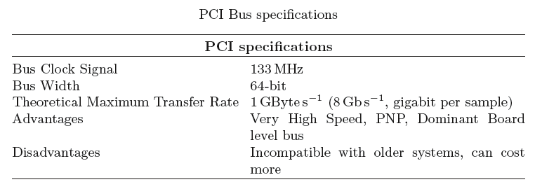

**PXI:**

PCI Extension for Instrumentation (PXI) was created in response to the needs of a variety of instrumentation and automation for users who require ever increasing performance, functionality, and reliability.

PXI leverages the electrical features defined by the widely adopted Peripheral Component Interconnect (PCI) specification. It also leverages the Compact PCI form factor, which combines the PCI electrical specification. This combination allows Compact PCI and PXI systems to have up to seven peripheral slots versus four in a desktop PCI system. The PXI Hardware Specification adds electrical features that meet the high-performance requirements of instrumentation applications by providing triggering, local buses, and system clock capabilities. PXI also offers two-way interoperability with Compact PCI products. By implementing desktop PCI in a rugged form factor, PXI systems can leverage the large base of existing industry-standard software.

PXI Architecture:

* The PXI chassis compares to the desktop’s enclosure
* The PXI controller compares to the desktop’s CPU, memory, and I/O
* The PXI(e) peripheral modules compare to the desktop’s PCI(e) peripheral modules

A PXI chassis can include the following:

* A system slot, which accepts an embedded or remote PXI Express controller
* PXI peripheral slots, which accept PXI modules
* PXI Express hybrid peripheral slots, which accept PXI Express peripheral modules, 32-bit Compact PCI peripheral modules, and hybrid-compatible PXI peripheral modules
* A system timing slot, which accepts both PXI Express peripheral modules and PXI Express system timing modules

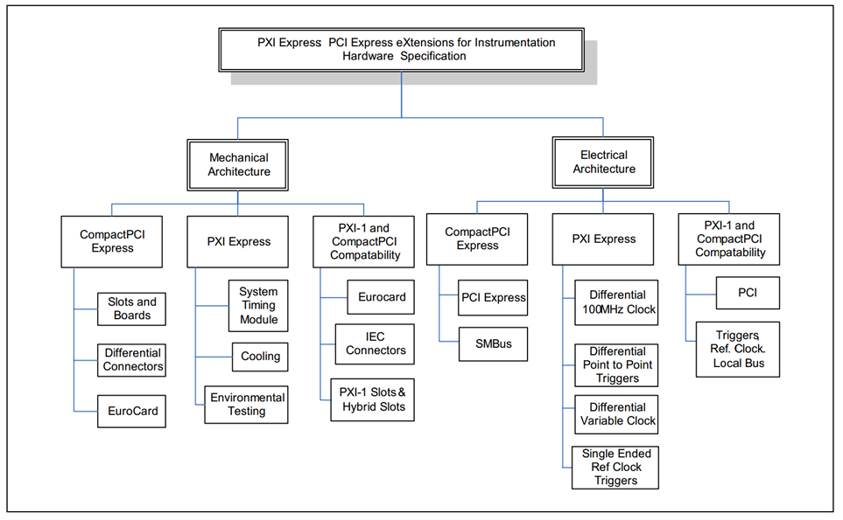

Electrical Architecture Overview:

For legacy instruments, PXI supports PCI communication—a 32-bit bus commonly used for transmitting and receiving data in parallel. The maximum bandwidth or throughput of a PCI instrument is 132 MB/s. As applications required higher bandwidth, PCI Express was defined where data is sent serially through pairs of transmit and receive connections called lanes, which give data the ability transfer at 250 MB/s per direction. This serial connection is known as a PCI Express Gen1 x1 “link” (by-one). Multiple lanes can be grouped together to form x2, x4, x8, x16, and x32 links to increase bandwidth. These links form a connection between a controller and a slot where an instrument is seated. For example, a x16 slot could transmit and receive 4 GB/s (250 MB/s * 16). To ensure compatibility with previous PXI instruments and new PXI Express instruments, both the PCI and PCI Express communication buses are incorporated into a PXI chassis. As the PCI Express specification evolves to the next generation, PXI will continue to incorporate the new capabilities into a PXI chassis while maintaining backward compatibility.

**PXI Controller:**

Most PXI chassis contain a slot for an internal system controller. This must be located in slot 1, the left most slot of the chassis. However, there are several options for a PXI controller:

Embedded PXI controller: The advantage of an embedded controller is that it removes the requirement for an external PC or laptop which adds to the space taken by the overall system.

Embedded controllers are complete with all the components necessary for a computer including the main CPU, RAM, hard disc drive, and all the relevant peripherals. They typically run Windows software and have all device drivers installed.

Laptop controller: For many applications, a laptop style PC is an ideal option. Having the integrated display, keyboard and other elements of the computer within the laptop package, it provides additional power and convenience for some applications. Typically a laptop controller option will require a PCMCIA interface to allow connection to the laptop.

The advantage of a laptop controller is that it gives more flexibility of operation to enable changes updates and for general operator interaction. While keyboards and displays, etc can be added to the embedded controller, the aim is that it will be a system in one box, and under these circumstances a laptop used as the controller may offer a better solution.

PC controller: The PC based controller for a PXI test system is often the best option for a laboratory. It has the capability to provide the highest level of control and performance.

In this configuration the control of the PXI system is run from PC through a software and driver-transparent link. During boot-up, the computer recognises all peripheral modules in the PXI system as PCI boards. When operating in this mode, the PXI cards are recognised as PCI cards and can be controlled in the normal way for PXI.

To provide PC control of a PXI system, a PCI/PCI Express board is required in the computer and a PXI/PXI Express module is needed in slot 1 of the PXI system. This can be connected via a traditional copper cable or where very high speeds or high data levels are needed a fibre optic cable could be used.

The standard defines the mechanical outlines for the PXI modules. These come in two heights - 3U and 6U.

The 3U PXI cards tend to be the more popular as they enable a much more compact system to be constructed.

The 3U modules have an ejector handle at the bottom of the module, one being sufficient to enable reliable easy ejection. However, a screw fixing is provided at the top and bottom of the module. This ensures that the module is firmly retained within the PXI rack even if there is some vibration. It also provides a good earth connection.

There are two positions for connectors. These are designated J1 and J2. The J1 connector is mandatory, as it carries the 32-bit PCI features. The J2 connector is optional because it carries the 64 bit PCI and PXI features which may not be needed and this can provide a good cost saving.

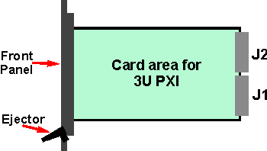

3U PXI module outline.

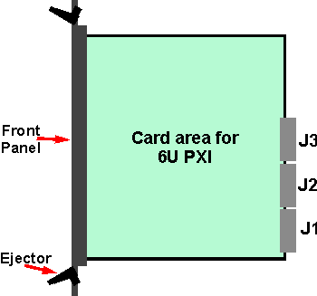

6U PXI module outline.

PXI software development

To develop programmes, software tools are now widely used. The same is true for automated programmes to run and control PXI systems.

The PXI software specification recommends, but does not mandate support for several commonly used software development environments.

• ATEasy, Geotest-Marvin Test Systems

• LabVIEW, National Instruments

• LabWindows/CVI, National Instruments

• Visual Basic, Microsoft

• Visual C/C++, Microsoft

The actual versions used can be found in the PXI Software Specification and will change as new versions of the development environments are released.

Instrument drivers play a very important role within the PXI software environment, enabling much easier communications with the various instruments used within the overall system.

The instrument drivers provide a high level method of communicating with the test instrument modules without the need to communicate directly with the registers of the test instrument in the low level command syntax.

There are two main types of driver that may be used:

VISA drivers: VISA stands for Virtual Instrument Software Architecture, and it was originally designed for VXI systems. However VISA has also been adopted for use in PXI software. In fact the PXI standard encourages the use of VISA.

IVI drivers: The abbreviation IVI stands for Interchangeable Virtual Instruments, and it is another standard for virtual instrumentation. IVI is supported by the IVI Foundation and it builds on top of VISA. It provides some interchangeability between instruments without the need for software reprogramming, if, for example there is a need to change from one instrument to another of the same class or type, e.g. if a change between two DC power supply types is required.

The use of IVI drivers, although not mandated by the PXI standard can provide additional flexibility when building a system, because it enables some interchangeability of modules, should one type become obsolete, and another be required, or if a system requires repair and the original module type is not available and a near alternative could be used.

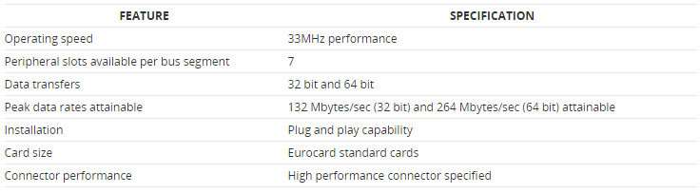

**PCMCIA:**

Personal Computer Memory Card International Association (PCMCIA) is an international standards body and trade association founded in 1989 developed a standard for small, credit card-sized devices, called PC Cards. Besides providing an industry standard interface for third-party cards (PC Cards), PCMCIA allows users to easily swap cards in and out of a PC as needed, without having to deal with the allocation of system resources for those devices. These useful features hot swapping and automatic configuration ,as well as card slot power management and other PCMCIA capabilities – are supported by a variety of software components on the PCMCIA-based PC.

Characteristics of PCMCIA:

– One rear slot, access from rear of PC

– Accept Type I/II/III Cards

– Comply with PCI Local Bus Specification Rev.2.2

– Comply with 1995 PC Card Standard

– Extra compatible registers are mapped in memory

– Use T/I 1410 PCMCIA controller

– Support PC Card with Hot Insertion and Removal

– Support 5V or 5/3.3V 16-bit PC Cards

– Support Burst Transfers to Maximize Data Throughput on both PCI Buses

– Supports Distributed DMA and PC/PCI DMA

Specifications:

– Power Supply Voltage: 5V

– Operation Temperature: 32–158*◦* F (0–70*◦* C)

– Storage Temperature: *−*4–185*◦* F (*−*20 *−* 85*◦* C)

– Relative Humidity: Max 90%

– Dimensions 128(H) *×* 134(W) *×* 20(D) mm

Board Layout and Jumper Settings:



Types of PC Cards:

1. Type I PC Cards are typically used for memory devices such as RAM, Flash, OTP, and SRAM cards.

2. Type II PC Cards are typically used for I/O devices such as data/fax modems, LANs, and mass storage devices.

3. Type III PC Cards are used for devices whose components are thicker, such a rotating mass storage devices.

All three-card types measure the same in length and width, and use the same 68-pin connector along the edge for connecting to a computer.

The only difference between the card types is thickness, which vary as 3.3, 5.0, and 10.5mm for Type I, Type II, and Type III cards, respectively. Because it differs only in thickness, a thinner card can be used in a thicker slot, but a thicker card cannot be used in a thinner slot.

Features of PC Card Technology:

1. Card Information Structure.

The CIS describes the characteristics and capabilities of the card so the host system can automatically configure it. CIS is defined in the Meta format Specification.

2. Card Bus.

Card Bus allows PC Cards and hosts to use 32-bit bus mastering and to operate at speeds up to 33 MHz.

3. DMA

The Standard allows cards to utilize Direct Memory Access technology

directly in the hardware when matched with a corresponding host system.

4. Execute In Place (XIP).

Allows operating system and application software to run directly from the PC Card, eliminating the need for large amounts of system RAM.

5. Low Voltage Operation

The Standard enables 3.3 and 5-V operation. A physical keying mechanism for 3.3-V cards protects them from being damaged in a 5-V slot.

6. Multiple Function PC Cards.

The Standard enables truly standardized multiple function PC-Cards.

7. Plug and Play.

PC Cards can be inserted or removed while the system is on because power and ground contact pins are the longest contacts, ensuring that disconnect signals disengage first, preserving data integrity.

8. Power Management.

The Standard provides a means to interface to Advanced Power Management (APM) through the Card Services Specification.

9. Zoomed Video (ZV).

ZV is a connection between a PC Card and host system that allows the card to write video data directly to the VGA controller. The data is transferred with no buffering requirements because it is transferred over the ZV bus and not the system bus.

Utilities of PCMCIA Card in the Networking Category:

Under the networking category, typically PCMCIA slot supports 4 types of cards such as:

– LAN card

– Wireless LAN card

– Modem card

– ATA flash disk card

Wireless networking is one of the most recent major advances in the world of telecommunications. The ability to communicate and send data without a physical connection is becoming more popular at a very quick rate. In other words, a wireless LAN is one in which a mobile user can connect to a local area network (LAN) through a wireless (radio) connection. A standard, IEEE 802.11, specifies the technologies for wireless LANs.

Features and Benefits:

– One, two, or four independent serial ports

– Speeds up to 921.6 kbps

– Auto enable/disable feature

– Removable cable standard

– Permanently attached rugged cable option for one and two port RS 232 cards

– 3.3 and 5V compatible

– Plug and Play and Hot Swap capability

– Low power requirements

– Linux support

– Windows CE and Pocket PC support

– Windows 9x/Me/NT/2000/XP and OS/2 support

**VXI:**

The VXI(VME eXtensions for Instrumentation) bus Consortium was formed in 1987 with a charter of defining a multivendor instrument-on-a-card standard. Since that time, the Consortium has defined system-level components required for hardware interoperatibility. The IEEE officially adopted the VXI specification, IEEE 1155, in March 1993. The VXIplug&play Systems Alliance, founded in September 1993, sought a higher level of system standardization to cover all VXI system components.

VXI is used in many different applications ranging from test and measurement and ATE, to data acquisition and analysis in both research and industrial automation. Although some VXI systems today are purely VXI, many users are migrating to VXI by integrating it into existing systems consisting of GPIB instruments, VME cards, or plug-in data acquisition (DAQ) boards.

The Need for VXIbus:

The demand for an industry-standard instrument-on-a-card architecture has been driven by the need for physical size reduction of rack-and-stack instrumentation systems, tighter timing and synchronization between multiple instruments, and faster transfer rates than the 1 Mb/s rate of the 8-bit GPIB. The modular form factor, high bandwidth, and commercial success of the VME bus made it particularly attractive as an instrumentation platform. The tremendous popularity of GPIB also made it attractive as a model for device communication and instrument control protocols. The VXI bus specification adds the standards necessary to combine the VME bus with GPIB to create a new, modular instrumentation platform that can meet the needs of future instrumentation applications.

VXI brings the following benefits to instrumentation users:

* Open, multivendor standards maximize flexibility and minimize obsolescence
* Increased system throughput reduces test time and/or increases capabilities
* Smaller size and higher density reduce floor space, enhance mobility or portability, and give close proximity to device(s) being tested or controlled
* More precise timing and synchronization improve measurement capability
* Standardized VXI plug&play software eases system configuration, programming, and integration
* Modular, rugged design improves reliability, increases mean time between failure (MTBF), and decreases mean time to repair (MTTR)

VXI Bus Mechanical Configuration:

Physically, a VXIbus system consists of a mainframe chassis that has the physical mounting and backplane connections for plug-in modules. The VXIbus uses the industry-standard IEEE-1014 VMEbus as a base architecture to build upon. VXI uses the full 32-bit VME architecture, but adds two board sizes and one connector. The P1 connector and the center row of the P2 connector are retained exactly as defined by the VME specification. The VME user-definable pins on the P2 connector and the additional pins on P3, the third VXI connector, implement instrumentation signals between plug-in modules directly on the backplane.

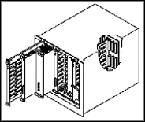

VXI bus System

The VXIbus specification includes packaging requirements, electromagnetic compatibility, power distribution, cooling, and airflow for VXI bus mainframes and plug-in modules. The modules are installed in the mainframe slots. LEDs, switches, test points, and I/O connections are accessible from the module front panel.

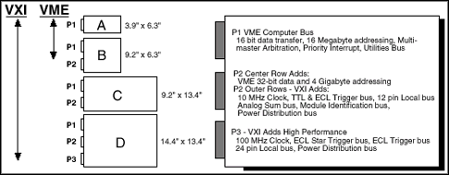

VXI Module Sizes

VXI modules must have a specific set of registers located at specific addresses. The upper 16 KB of the 64 KB A16 address space are reserved for VXIbus devices. Each VXI device has an 8-bit logical address that specifies where its registers are located in this address space. A single VXI system can have up to 256 VXI devices. The logical address of a VXI device, which can be manually set or automatically configured by the system at startup, is analogous to the GPIB address of a GPIB device.

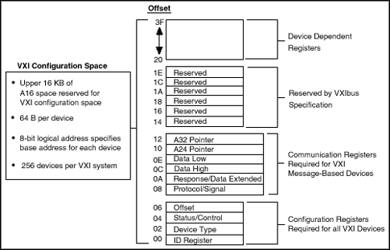

VXI Configuration Registers

Register-Based Devices:

The system can identify each VXI device, its type, model and manufacturer, address space, and memory requirements. VXIbus devices with only this minimum level of capability are called Register-Based devices. With this common set of configuration registers, the centralized Resource Manager (RM), essentially a software module, can perform automatic system and memory configuration when the system is initialized.

Message-Based Communication:

All Message-Based VXI bus devices, regardless of the manufacturer, can communicate at a minimum level using the VXI-specified Word Serial Protocol. When minimum communication is possible, higher-performance communication channels, such as shared-memory channels, can be established to take advantage of the VXI bus bandwidth capabilities.

Word Serial Protocol:

The VXIbus Word Serial Protocol is functionally very similar to the IEEE-488 protocol, which transfers data messages to and from devices one byte (or word) at a time. Thus, VXI Message-Based devices communicate in a fashion very similar to IEEE-488 instruments. In general, Message-Based devices typically contain some level of local intelligence that uses or requires a high level of communication.

All VXI Message-Based devices are required to use the Word Serial Protocol to communicate in a standard way. The protocol is called word serial, because if we want to communicate with a Message-Based device, we do so by writing and reading 16-bit words one at a time to and from the Data In (write Data Low) and Data Out (read Data Low) hardware registers located on the device itself. Word Serial communication is paced by the bits in the response register of the device, indicating whether the Data In register is empty and whether the Data Out register is full. This operation is very similar to Universal Asynchronous Receiver Transmitter (UART) on a serial port.

Commander/Servant Hierarchies:

The VXIbus defines a Commander/Servant communication protocol so you can construct hierarchical systems using conceptual layers of VXI devices. This structure is like an inverted tree. A Commander is any device in the hierarchy with one or more associated lower-level devices, or Servants. A Servant is any device in the subtree of a Commander. A device can be both a Commander and a Servant in a multiple-level hierarchy.

A Commander has exclusive control of the communication and configuration registers of its immediate Servants (one or more). Any VXI module has one and only one Commander. Commanders communicate with Servants through the communication registers of the Servants using the Word Serial Protocol if the Servant is a Message-Based device, or by device-specific register manipulation if the Servant is a Register-Based device. Servants communicate with their Commander by responding to the Word Serial commands and queries from their Commander through the Word Serial protocol if they are Message-Based, or by device-specific register status if they are Register-Based.

Interrupts and Asynchronous Events:

Servants can communicate asynchronous status and events to their Commander through hardware interrupts or by writing specific messages (signals) directly to their Commander's hardware Signal Register. Nonbusmaster devices always transmit such information via interrupts, whereas devices that have busmaster capability can either use interrupts or send signals. Some Commanders can receive signals only, whereas others might be only interrupt handlers.

The VXIbus specification contains defined Word Serial commands so that a Commander can understand the capabilities of its Message-Based Servants and configure them to generate interrupts or signals in a particular way. For example, a Commander can instruct its Servants to use a particular interrupt line, to send signals rather than generate interrupts, or configure the reporting of only certain status or error conditions.

The leftmost slot of a VXI chassis has special system resources such as backplane clocks, configuration signals, and synchronization (trigger) signals and therefore must be occupied by a device with VXI “Slot 0” capabilities. The VXI Resource Manager (RM) function, essentially a software module, can reside on any VXI module or even on an external computer. The RM, in combination with the Slot 0 device, identifies each device in the system, assigns logical addresses, memory configurations, and establishes Commander/Servant hierarchies using the Word Serial Protocol to grant Servants to the Commanders in the system. After establishing the Commander/Servant hierarchy, the RM issues the Begin Normal Operation Word Serial command to all top-level Commanders. During normal system operation, the RM may also halt the system and/or remap the hierarchy if necessary.

Three Ways to Control a VXI System:

System configuration is divided into three categories. The first type of VXI system consists of a VXI mainframe linked to an external controller via the GPIB. The controller talks across the GPIB to a GPIB-VXI interface module installed inside the VXI mainframe. The GPIB-VXI interface transparently translates the GPIB protocol to and from the VXI Word Serial protocol.

The second configuration involves a VXI-based embedded computer. The embedded computer is a VXI module that resides inside the VXI mainframe and connects directly to the VXI backplane. This configuration offers the smallest physical size for a VXI system as well as performance benefits due to direct connection to the VXI backplane.

The third configuration uses a high-speed MXIbus link from an external computer to control the VXI backplane. The external computer operates as though it is embedded directly inside the VXI mainframe. This configuration is functionally equivalent to the embedded method, except that it has the flexibility for use with a wide variety of computers and workstations.

Software Standards:

One of the most important considerations when selecting a VXI system is software. Software is the key to developing successful systems based on the VXIbus. There are many programming languages, operating systems, and application development environments (ADE) to choose from when building a VXI system. It is important to make the right decisions to realize all of the advantages that VXI has to offer, while minimizing your development costs now and in the future.

With the VISA standard endorsed by over 50 of the largest instrumentation companies in the industry including Tektronix, Hewlett-Packard, and National Instruments, VISA unifies the industry by facilitating the development of interoperable and reusable software components able to stand the test of time. Before VISA, there were many different commercial implementations of I/O software for VXI, GPIB, and serial interfaces; however, none of these I/O software products were standardized or interoperable.

Advantages of VXI:

* VXI is an open standard with over 1200 commercial VXI products from variety of manufacturers.
* User can configure systems with off-the-shelf building blocks.
* VXI framework is fully shielded with high level of electromagnetic protection.
* 32-bit VME bus is used as the major channel for backplane communication.
* Includes features like local bus for intermodule communication, timing and trigger control unit and precision clock.
* The modules in the VXI chassis support geographic addressing.
* More easy to configure and integrate due to the plug and play capability.
* High speed operation resulting from the use of a single high speed rack and backplane.

SCSI - Small Computer System Interface:

The Small Computer System Interface (SCSI) is a set of parallel interface standards developed by the American National Standards Institute (ANSI) for attaching printers, disk drives, scanners and other peripherals to computers. SCSI (pronounced "skuzzy") is supported by all major operating systems.

SCSI uses a controller to send and receive data and power to SCSI-enabled devices, like hard drives and printers.

SCSI has several benefits. It's fairly fast, up to 320 megabytes per second (MBps). It's been around for more than 20 years and it's been thoroughly tested, so it has a reputation for being reliable. Like Serial ATA and FireWire, it lets you put multiple items on one bus. SCSI also works with most computer systems.

SCSI has three basic specifications:

SCSI-1: The original specification developed in 1986, SCSI-1 is now obsolete. It featured a bus width of 8 bits and clock speed of 5 MHz.

SCSI-2: Adopted in 1994, this specification included the Common Command Set (CCS) -- 18 commands considered an absolute necessity for support of any SCSI device. It also had the option to double the clock speed to 10 MHz (Fast), double the bus width from to 16 bits and increase the number of devices to 15 (Wide), or do both (Fast/Wide). SCSI-2 also added command queuing, allowing devices to store and prioritize commands from the host computer.

SCSI-3: This specification debuted in 1995 and included a series of smaller standards within its overall scope. A set of standards involving the SCSI Parallel Interface (SPI), which is the way that SCSI devices communicate with each other, has continued to evolve within SCSI-3. Most SCSI-3 specifications begin with the term Ultra, such as Ultra for SPI variations, Ultra2 for SPI-2 variations and Ultra3 for SPI-3 variations. The Fast and Wide designations work just like their SCSI-2 counterparts. SCSI-3 is the standard currently in use.

All of these SCSI types are parallel -- bits of data move through the bus simultaneously rather than one at a time. The newest type of SCSI, called Serial Attached SCSI (SAS), uses SCSI commands but transmits data serially. SAS uses a point-to-point serial connection to move data at 3.0 gigabits per second, and each SAS port can support up to 128 devices or expanders.

A SCSI controller coordinates between all of the other devices on the SCSI bus and the computer. Also called a host adapter, the controller can be a card that you plug into an available slot or it can be built into the motherboard. The SCSI BIOS is also on the controller. This is a small ROM or Flash memory chip that contains the software needed to access and control the devices on the bus.

SCSI connectors:

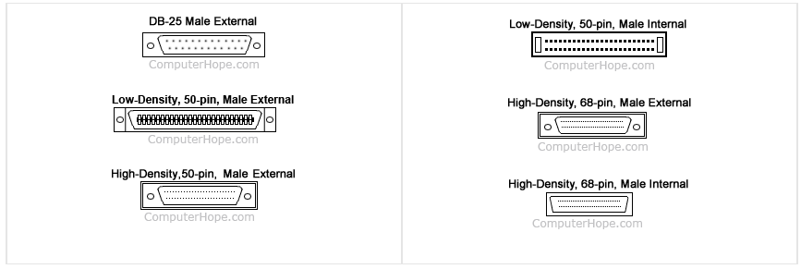

Different SCSI Technologies:

Debuting in 1986, the very first version of SCSI supported 8 devices with a maximum transfer speed of 5 MBps. Faster versions came later, with speeds like 320 MBps with support for 16 devices.

* **Fast SCSI:** 10 MBps; connects 8 devices
* **Fast Wide SCSI:**20 MBps; connects 16 devices
* **Ultra Wide SCSI:** 40 MBps; connects 16 devices
* **Ultra3 SCSI:** 160 MBps; connects 16 devices
* **Ultra-640 SCSI:** 640 MBps; connects 16 devices

external SCSI devices typically have two SCSI connectors -- one to connect to the previous device in the chain, and the other to connect to the next device.

The cable itself typically consists of three layers:

* **Inner layer:** The most protected layer, this contains the actual data being sent.
* **Media layer:** Contains the wires that send control commands to the device.
* **Outer layer:** Includes wires that carry parity information, which ensures that the data is correct.

Different SCSI variations use different connectors, which are often incompatible with one another. These connectors usually use 50, 68 or 80 pins. SAS uses smaller, SATA-compatible connectors.

Types of SCSI termination can be grouped into two main categories: passive and active. Passive termination is typically used for SCSI systems that run at the standard clock speed and have a distance of less than 3 feet (1 m) from the devices to the controller. Active termination is used for Fast SCSI systems or systems with devices that are more than 3 feet (1 m) from the SCSI controller.

Each SCSI device must have a unique identifier (ID) in order for it to work properly. For example, if the bus can support sixteen devices, their IDs, specified through a hardware or software setting, range from zero to 15. The SCSI controller itself must use one of the IDs, typically the highest one, leaving room for 15 other devices on the bus.

SCSI Vendors:

The following vendors are part of INCITS Technical Committee 10, which sets protocols for SCSI and related technologies. These suppliers provide everything from cable connectors to complete computers and storage systems.

* 3M Company
* Agilent Technologies
* Amphenol Interconnect
* Applied Micro Circuits Corporation
* Pegatron Corporation
* Pericom Semiconductor Corporation
* QLogic
* QNAP Systems
* Quantum
* SMART Modular Technologies
* STEC
* Samsung Information Systems and etc

Some computer manufacturers have stopped using on-board SCSI completely, and use standards that are now much more popular, like USB and FireWire, for connecting external devices to computers. USB is also much faster, with maximum speeds of 1250 MBps (10 Gbps).

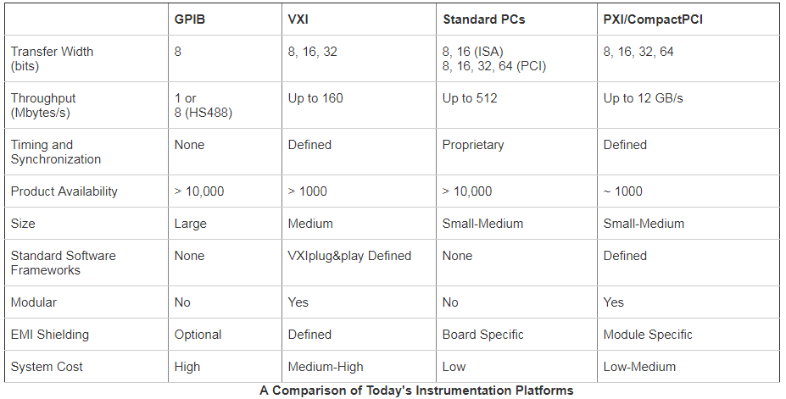

**FireWire:**

Originally created by Apple and standardized in 1995 as the specification **IEEE 1394 High Performance Serial Bus**, FireWire is very similar to Universal Serial Bus (USB). The designers of FireWire had several particular goals in mind when they created the standard:

* Fast transfer of data
* Ability to put lots of devices on the bus
* Ease of use
* Hot-pluggable ability
* Provision of power through the cable
* Plug-and-play performance
* Low cabling cost
* Low implementation cost

FireWire is a method of transferring information between digital devices, especially audio and video equipment. Also known as IEEE 1394, FireWire is fast -- the latest version achieves speeds up to 800 Mbps. At some time in the future, that number is expected to jump to an unbelievable 3.2 Gbps when manufacturers overhaul the current FireWire cables. The 1394 interface is also known by the brand i.LINK (Sony), and Lynx (Texas Instruments).

You can connect up to **63 devices** to a FireWire bus. Windows operating systems (98 and later) and Mac OS (8.6 and later) both support it.

FireWire is **plug-and-play**, so if you connect a new FireWire device to your computer, the operating system auto-detects it and asks for the driver disc. If you've already installed the device, the computer activates it and starts talking to it. FireWire devices are **hot pluggable**, which means they can be connected and disconnected at any time, even with the power on.

FireWire Versions

IEEE 1394, first called FireWire 400, was released in 1995. It uses a 6-pin connector and can transfer data at 100, 200, or 400 Mbps (depending on the FireWire cable used) on cables as long as 4.5 meters. These data transfer modes are commonly called S100, S200, and S400.

In the year 2000, IEEE 1394a was released, which provided improved features like a power-saving mode. IEEE 1394a uses a 4-pin connector instead of the 6 pins that exist in FireWire 400 because it doesn't include power connectors.

Just two years later came IEEE 1394b, called FireWire 800, or S800. This 9-pin version of IEEE 1394a supports transfer rates up to 800 Mbps on cables up to 100 meters in length. The connectors on the cables for FireWire 800 are not the same as those on FireWire 400, which means the two are incompatible with each other unless a conversion cable or dongle is used.

In the late 2000's, FireWire S1600 and S3200 were detailed that supported transfer speeds as fast as 1,572 Mbps and 3,145 Mbps.

However, so few of these devices were released that they shouldn't even be considered as part of the "timeline" of FireWire developments.

In 2011, Apple began replacing FireWire with the much faster Thunderbolt and, in 2015, at least on some of their computers, with USB 3.1 compliant USB-C ports.

Specifications:

The original FireWire specification, FireWire 400 (1394a), was faster than USB when it came out. FireWire 400 is still in use today and features:

* Transfer rates of up to **400 Mbps**
* Maximum distance between devices of 4.5 meters (cable length)

The release of USB 2.0 -- featuring transfer speeds up to 480 Mbps and up to 5 meters between devices -- closed the gap between these competing standards. But in 2002, FireWire 800 (1394b) started showing up in consumer devices, and USB 2.0 was left in the dust.

FireWire 800 is capable of:

* Transfer rates up to **800 Mbps**
* Maximum distance between devices of **100 meters** (cable length)

The faster 1394b standard is **backward-compatible** with 1394a.

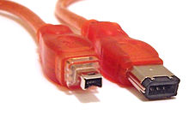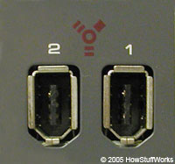

FireWire vs. USB

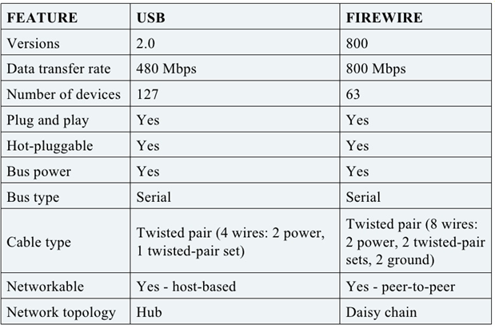

FireWire Cables and Connectors:

FireWire devices can be powered or unpowered. FireWire allows devices to draw their power from their connection. Two power conductors in the cable can supply power (8 to 30 volts, 1.5 amps maximum) from the computer to an unpowered device. Two twisted pair sets carry the data in a FireWire 400 cable using a 6-pin configuration.

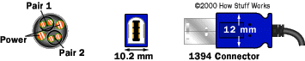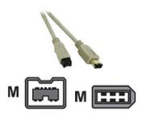

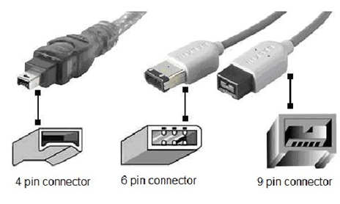

FireWire 800 cables use a 9-pin configuration.

Sending Data via FireWire:

FireWire uses 64-bit fixed addressing, based on the IEEE 1212standard. There are three parts to each packet of information sent by a device over FireWire:

* A 10-bit **bus ID** that is used to determine which FireWire bus the data came from
* A 6-bit **physical ID** that identifies which device on the bus sent the data
* A 48-bit **storage area** that is capable of addressing 256 terabytes of information for each node

The bus ID and physical ID together comprise the 16-bit **node ID**, which allows for 64,000 nodes on a system. Data can be sent through up to 16 **hops** (device to device). Hops occur when devices are **daisy-chained**together. Look at the example below. The camcorder is connected to the external hard drive connected to Computer A. Computer A is connected to Computer B, which in turn is connected to Computer C. It takes four hops for Computer C to access the camera.

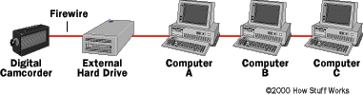

**VISA:**

Virtual Instrumentation Software Architecture (VISA) is a standard I/O language for instrumentation programming. The Virtual Instrument Software Architecture (VISA) is a standard for configuring, programming, and troubleshooting instrumentation systems comprising GPIB, VXI, PXI, Serial, Ethernet, and/or USB interfaces. VISA provides the programming interface between the hardware and development environments such as LabVIEW, LabWindows/CVI, and Measurement Studio for Microsoft Visual Studio.

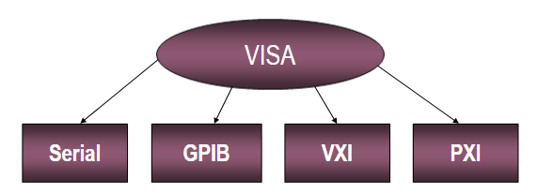

VISA Architecture

Supported Platforms and Environments:

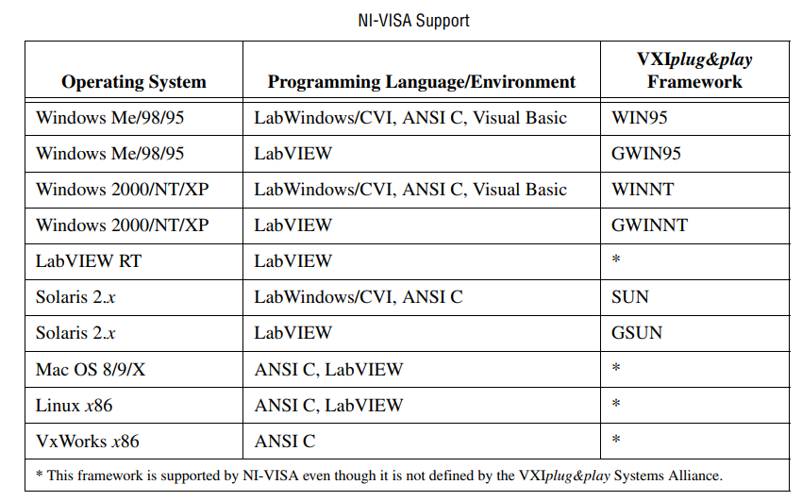

Advantages of VISA:

One of VISA's advantages is that it uses many of the same operations to communicate with instruments regardless of the interface type. For example, the VISA command to write an ASCII string to a message-based instrument is the same whether the instrument is Serial, GPIB, or USB. Thus, VISA provides interface independence. This can make it easy to switch interfaces and also gives the users who must program instruments for different interfaces a single language they can learn.

VISA is also designed so that programs written using VISA function calls are easily portable from one platform to another. VISA does this by defining its own data types. This prevents problems like, for example, possible problems caused by moving from one platform to another where the size of an integer may be different. In other words, a LabVIEW application written with VISA calls can be easily ported to another platform that supports LabVIEW. Several operating systems are supported, including Windows XP/64, Windows 2000/ME/98, MAC OS X/9/8, some Linux distrubutions, as well as some Solaris distributions.

VISA's greatest advantage is that it is an extremely easy language to learn. VISA provides a very simple-to-use API that has bus independent functions for most of its I/O functionality. VISA provides the most commonly used functionality for instrumentation in a very compact command set, eliminating the need to learn low level communication protocals for multiple bus types.

VISA Terminology:

The most important objects in the VISA language are known as resources. A VISA Resource is any instrument in your system (this includes serial and parallel ports). If you have multiple resources connected to one GPIB controller, each of those instruments is considered a VISA Resource.

An Instrument Descriptor is the exact name of a resource. It specifies the interface type (GPIB, serial, USB), the address of the device (logical address or primary address) and the VISA Session type (INSTR, Event, or INTFC). A VISA session is a path of communication to a VISA Resource, so you must open a VISA Session any time you want to do VISA communication to an instrument. A VISA Alias is basically a nickname for a VISA Resource. You could give an instrument located on [GPIB0::3::INSTR] a visa alias of "Function Generator".

VISA Programming:

*Resources*. The most important objects in the VISA language are known as resources.

*Operations*. In object-oriented terminology, the functions that can be used with an object are known as operations.

*Attributes*. In addition to the operations that can be used with an object, the object has variables associated with it that contain information related to the object. In VISA, these variables are known as attributes.

There is a default resource manager at the top of the VISA hierarchy that can search for available resources or open sessions to them. Resources can be GPIB, serial message based VXI, or register-based VXI. The most common operations for message based instruments are read and write. The most common operations for register based Instruments are In’s and Out’s.

DEFAULT Resource Manager, Session, and Instrument Descriptors:

The Default Resource Manager is at the highest level of VISA operations. Communication must be established with the Resource Manager at the beginning of any VISA program.

– Resource. An instrument or controller.

– Session. A connection, or link, to the VISA Default Resource Manager or a resource.

The VISA Find Resources VI that carries out the operation of searching for available resources in the system. This VI is a common starting point for a VISA Program. It can be used to determine if all of the necessary resources for the application to run are available. The only necessary input to the VISA Find Resources VI is a string called the search expression. This string determines the types of resources returned by the Find Resources VI.

The important return values of the VI are the return count which simply reports the Number of resources that were found and the find list. The find list is an array of strings. Each string contains the description of one of the resources that was found. These strings are known as instrument descriptors.

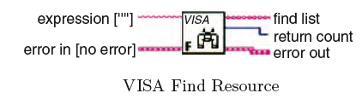

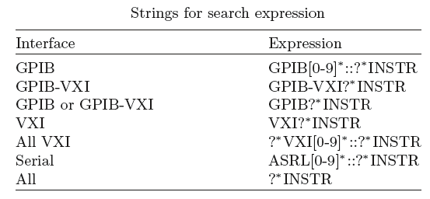

– INSTRUMENT Descriptor. The exact name and location of a VISA resource, this string has the format Interface Type [Board Index]::Address ::VISA Class.

For example, if the system contains two GPIB plug-in boards which could be referred to as GPIB0 and one as GPIB1. In this case, the board index needs to be used in Instrument descriptors. For VXI instruments, the “Address” parameter is the Logical Address of the instrument. For GPIB instruments, it is the GPIB primary address. For Serial instruments the address is not used. An example is “ASRL1::INSTR” as the Descriptor for the COM1 serial port on a personal computer.

– Class. The VISA Class is a grouping that encapsulates some or all of the VISA operations. INSTR is the most general class that encompasses all VISA operations.

The instrument descriptors are used to open sessions to the resources in the system using the Default Resource Managers ability to open sessions. The VISA Open VI carries out this operation.



**VISA session and control**

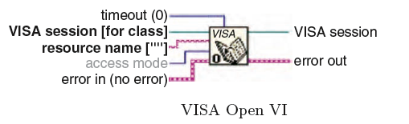

In order to open sessions to resources in LabVEIW, a VISA Session front panel control is needed.



**VISA session front panel**



**VISA Close VI**



**Open session**

The important input to the VISA Close VI is the session to be closed. This session originally comes from the output session terminal of the VISA Open VI. If a session is not closed when a VI is run, that session will remain open. It is a good idea to always close any sessions that are opened in an application so open sessions do not build up and cause problems with system resources. If a VI runs and leaves a session open without closing it – this session can still be used in the later VIs.

The open session’s choice of the front panel VISA Session control can be used to check if any sessions are currently open. Accessing open sessions by popping up on front panel VISA Session Controls also provides a convenient way to interactively run parts of an Instrument driver.

**Error Handling with VISA:**

Error handling with VISA VIs is similar to error handling with other I/O VIs in LabVIEW. Each of the VISA VIs contains Error Input and Error Output terminals that are used to pass error clusters from one VI to another. The error cluster contains a Boolean flag indicating whether an error has occurred, a numeric VISA error code, and a string containing the location of the VI where the error occurred.

If an error occurs, subsequent VIs will not try to execute and will simply pass on the error cluster. A front Panel error cluster indicator showing the output from the error out terminal of a VISA function as shown in below figure.



Error cluster

The inputs to this VI are a VISA session and a VISA error cluster. The VI will check the VISA code in the error cluster that was passed to it and output the text description of the code from the status description terminal.

This VI allows a text description of the status after a VISA VI executes to be used in a program. A LabVIEW string indicator displaying the error string returned from the VISA Status Description VI is also obtained. The exact method used for implementing error handling will depend on the nature of the program.

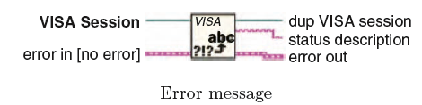



Front Panel error cluster

VISAIC and Message-Based Combination:

VISA comes with a utility called VISA Interactive Control (VISAIC) on all platforms that Support VISA and LabVIEW (except the Macintosh). This utility provides access to all of VISA’s functionality interactively, in an easyto- use graphical environment.

When VISAIC runs it automatically finds all of the available resources in the system and lists the instrument descriptors for each of these resources under the appropriate resource type.

The Soft Front Panels tab of the main VISAIC panel will give the option to launch the soft front panels of any VXI plug and play instrument drivers that have been installed on the system. The NI I/O tab will give the option to launch the NI-VXI interactive utility or the NI-488 interactive utility. This gives convenient links into the interactive utilities for the drivers VISA calls in case would like to try debugging at this level.

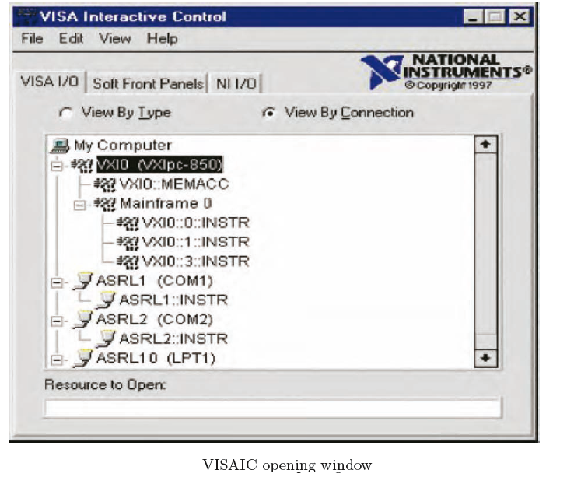

For VXI instruments, VISAIC also attempts to access one of the configuration registers on each instrument to verify its existence. VISAIC can also serve as a very useful debugging tool when problems arise in writing a program or in using a pre-existent application using VISA VIs.

Message-Based Communication:

Serial, GPIB, and many VXI devices recognize a variety of message-based command strings. At the VISA level, the actual protocol used to send a command string to an instrument is transparent. The user can only write a message or read a message from a message-based device. The VIs that are used to perform these operations are VISA Write and VISA Read.

The VISA Write VI is writes data to the device synchronously or asynchronously depending on the platform it is being used. The VISA Read VI is equally easy to use. The VISA Read VI must be given a byte count input equal to the maximum number of bytes that should be read from the instrument. The VI will terminate the read when this number of bytes has been read or when the end of the transfer is indicated.



VISAIC preferences

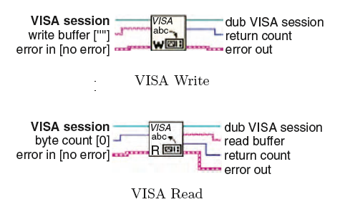

However, pre-written instrument drivers exist for many message-based devices. These instrument drivers contain functions that put together the appropriate ASCII command strings and send them to the instrument. A simple example that writes the ∗IDN string to a message-based instrument and reads the response as shown below figure.



Message-based instrument

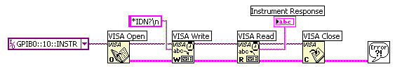

Register-Based Communication:

VISA contains a set of register access VIs for use with VXI instruments. Some VXI instruments do not support message-based commands. The only way to communicate with these instruments is through register accesses. All VXI instruments have configuration registers in the upper 16 kbytes of the memory space.

There are actually three different versions of this operation for reading a 8-, 16-, or 32-bit value. This function reads in a 16-bit word from a specified address space assigned with a memory base and offset. The valid address space values are:

– A16 Space: 1

– A24 Space: 2

– A32 Space: 3

There is another set of high level register access operations that parallel the VISA In operations, but are used for writing to registers. These operations are the VISA Out operations as shown below figure.

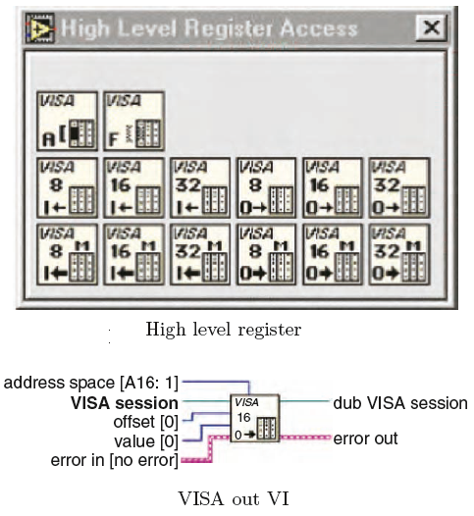

An example of using the high level VISA access functions in a VI is shown in the simple program. The program asks the user for the instrument descriptor and the offset of the configuration register to be read and returns the value from the register. If an error occurs in the sequence of VISA VIs that execute in the program, the Simple Error Handler will pop up a dialogue box informing the user about the status of the error and outputs a text message associated with the VISA Error Code.



Illustration of VISA Access Functions

VISA Attributes:

In addition to the basic communication operations, VISA resources have a variety of attributes whose values can be read or set in a program. In a LabVIEW program, these attributes are handled programmatically similar to the properties of front panel controls and indicators. Attribute nodes are used to read or set the values of VISA attributes.

The VISA attribute node contains a single attribute terminal when it is placed initially on the block diagram. However, it can be resized to contain as many different terminals as necessary. The initial terminal on the VISA attribute node is a read terminal. This means that the value of the attribute selected in that terminal will be read.

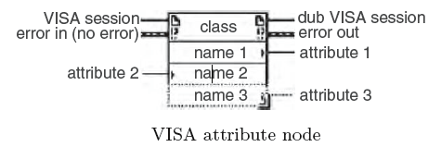

The attribute in each terminal of the attribute node can be selected by popping up on the attribute node terminal and choosing “Select Item.” This will provide a list of all the possible attributes that can be set in the program. This will produce a long list of attributes. The number of different attributes that are shown under the Select Item choice of the VISA Attribute Node can be limited.

Some of the common attributes for each resource type are shown in the list.

**Serial**

Serial baud rate: The baud rate for the serial port.

Serial data bits: The number of data bits used for serial transmissions.

Serial parity:The parity used for serial transmissions.

Serial stop bits:The number of stop bits used for serial transmissions.

**GPIB**

GPIB Readdressing: Specifies if the device should be readdressed before every

write operation.

GPIB Unaddressing: Specifies if the device should be unaddressed after read

and write Operations.

**VXI**

Mainframe logical address: The lowest logical address of a device in the same

chassis With the resource.

Manufacturer identification: The manufacturer ID number from the device’s

Configuration registers.

Model code:The model code of the device from the device’s configuration registers.

Slot. The slot in the chassis that the resource resides in.

VXI logical address: The logical address of the device.

VXI memory address space: The VXI address space used by the resource.

VXI memory address base: The base address of the memory region used by the resource.

VXI memory address size: The size of memory region used by the resource.

Advantages of VISA:

One of VISA's advantages is that it uses many of the same operations to communicate with instruments regardless of the interface type. For example, the VISA command to write an ASCII string to a message-based instrument is the same whether the instrument is Serial, GPIB, or USB. Thus, VISA provides interface independence. This can make it easy to switch interfaces and also gives the users who must program instruments for different interfaces a single language they can learn.

VISA's greatest advantage is that it is an extremely easy language to learn. VISA provides a very simple-to-use API that has bus independent functions for most of its I/O functionality.

**Interchangeable Virtual Instruments (IVI):**

Interchangeable Virtual Instruments, or IVI, is a revolutionary standard for instrument driver software technology. IVI builds on the VXIplug&play specifications and incorporates new features that address issues such as system performance, development flexibility, and instrument interchangeability. IVI drivers also take advantage of the power of the VISA I/O library defined by VXIplug&play to seamlessly communicate with instruments across different I/O buses such as GPIB, VXI, PXI, Serial, Ethernet, and USB.

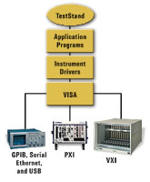

The IVI Foundation is the industry consortium that drives this standardization effort. Formed by National Instruments in August of 1998, the IVI Foundation has grown to more than 25 members, including end-users, system integrators, and software and instrument vendors. The Foundation's goals are to define standard specifications for programming common test instrument capabilities. The Foundation delivers specifications for interchangeable, better performing, and more easily maintainable instrument drivers.

Why IVI?

For years, test software developers have faced similar problems when writing code to programmatically communicate with their instruments. Specifically, each instrument in their systems required a different set of commands to perform a specific action, with no simple, standardized communication protocol in place to program their instruments. Companies wasted valuable time and money training their developers to write software for instruments. Moreover, when instruments were upgraded, developers could not reuse the software; they often had to learn a new protocol or a different set of commands.

The IVI specifications provide a standard for instrument drivers that addresses the performance issues demanded by test system developers and provides a robust framework for interchanging instruments. IVI specifications subdivide instruments into classes such as digital multimeter or oscilloscope. They then create a specification for that class based on the most common features and functionality of the most popular instruments within that class. The IVI Foundation, the standards body overseeing the development of these specs, has already defined specifications for thirteen instrument classes. The table below provides a list of all these classes.

IVI is one of three different types of LabVIEW and LabWindows/CVI instrument drivers that National Instruments provides to meet your needs. Depending on your specific requirements, you can use any of the following types of drivers.

IVI Architecture:

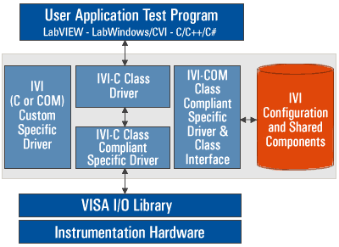

IVI is an integral component of a complete National Instruments test system. IVI sits above the VISA I/O layer in the program hierarchy and is integrated into the application development environments that National Instruments provides. The IVI architecture breaks the traditional instrument driver into two parts – an instrument-specific driver and a class driver. The instrument-specific driver functions the way traditional instrument drivers have in the past, but with an underlying architecture that is optimized for performance and includes instrument simulation. The class instrument driver contains generic functions for controlling an instrument category and calls the corresponding instrument-specific driver functions at run time. You can write your test program with either the class driver or the specific driver, but only programs written to the class driver are interchangeable.

In addition, the IVI Foundation has defined the IVI architecture to work with two interface technologies, one based on the ANSI C standard and one on Microsoft COM (Component Object Model) technology. The two architecture types are designed to be interoperable. The IVI drivers that National Instruments provides are based on the IVI-C architecture, as it offers many benefits over IVI-COM (see a more detailed comparison of IVI-C vs. IVI-COM):

* Stability and Robustness

IVI-C is based on the industry-proven VXIplug&play specifications and was the basis of the original IVI standard released in 1998. IVI-COM, based on technology that has already been superseded by .NET, is new to the IVI specifications, having been added in January 2003.

* Source Code Availability

Source code is generally available for IVI-C drivers but not for IVI-COM drivers.

* Driver Usability in Development Environments

IVI-C drivers are native in C environments, including LabWindows/CVI. The IVI-C drivers provided by National Instruments have custom wrappers optimized for LabVIEW; they can also be used in Visual Basic. IVI-COM drivers are native in Visual Basic and are usable, but not optimal, in other environments.

IVI Drivers:

IVI Drivers are sophisticated instrument drivers that feature increased performance and flexibility for your more intricate test applications that require interchangeability, state-caching, or simulation of instruments. To achieve interchangeability, the IVI Foundation has defined specifications for the following thirteen instrument classes: DMM, oscilloscope, arbitrary waveform/function generator, DC power supply, switch, power meter, spectrum analyzer, RF signal generator, counter, digitizer, downconverter, upconverter, and AC power supply. Certified IVI drivers are technically supported by National Instruments.

Plug and Play Instrument Drivers:

Plug and Play Instrument Drivers simplify controlling and communicating with your instrument through a standard and simple programming model for all drivers. LabVIEW and LabWindows/CVI Plug and Play instrument drivers comply with requirements and recommendations for programming style, error handling, front panels, block diagrams, icons, and online help. Because Plug and Play drivers maintain a common architecture and interface, you quickly and easily connect to and communicate with your instruments with very little or no code development. Certified Plug and Play instrument drivers are technically supported by National Instruments, while Plug and Play instrument drivers are supported by instrument vendors or other third parties.

Contributed Instrument Drivers:

Contributed Instrument Drivers are included “as is” and typically solve a specific application rather than acting as a fully functional instrument driver. Contributed instrument drivers are not supported by National Instruments or other third parties.

IVI Instrument Classes:

* Digital Multimeter
* Oscilloscope
* DC Power Supply
* Arbitrary Waveform/Function Generator
* Switch
* Power Meter
* Spectrum Analyzer
* RF Signal Generator
* Counter
* Digitizer
* Downconverter
* Upconverter
* AC Power Supply

**Benefits of IVI:**

IVI instrument driver technology offers the test system developer many advantages over existing implementations. IVI drivers are designed to provide the following benefits:

**High performance**

IVI drivers deliver a dramatic improvement in performance. These drivers integrate a powerful state-caching engine, which keeps track of the hardware settings of an instrument. This feature can improve test performance significantly, since it allows IVI drivers to behave intelligently and perform instrument I/O only when the value of a hardware setting needs modification. IVI drivers are also multithreaded safe, meaning you can build advanced multithreaded test programs using these drivers right out of the box, greatly increasing your test throughput.

**Instrument Simulation**

IVI drivers have built-in instrument simulation capabilities. With this feature, you can develop large amounts of your test code while your instruments are used in other systems, are temporarily unavailable, or are in the process of being delivered. You can generate simulated data in two different ways: using instrument-specific drivers in simulation mode or by using advanced class simulation drivers available with the IVI Compliance Package.

**Instrument Interchangeability**

IVI drivers are interchangeable across instruments, which has been a goal of test system engineers involved in a wide variety of application areas and industries. Specifications exist for instrument classes, along with a standard API for programming instruments that belong to a particular class. This industry-standard API has many far-reaching benefits, including but not limited to long-term test code maintenance, ease of programming, resulting in faster code development, and code reusability and reduced software maintenance costs.

**Development Flexibility**

IVI drivers are easy to develop using the Instrument Driver Development Wizard, which is built into LabWindows/CVI. The Wizard greatly reduces driver development time by creating code and function tree templates based on the selected instrument class. IVI drivers are also easy to use. All of National Instruments' IVI drivers work with our popular development environments, including LabVIEW, LabWindows/CVI, Measurement Studio for Microsoft Visual Studio, and TestStand.